CUSTOMER CHURN PREDICTION AND ANALYSIS USING MACHINE LEARNING
Aim
To analyze customer churn data using Exploratory Data Analysis (EDA), visualize important customer patterns, build a Logistic Regression model to predict customer churn, evaluate the model, and export the processed data to Excel.
Procedure
1. Download the Telco Customer Churn dataset from Kaggle.
2. Import the required Python libraries such as Pandas, Matplotlib, Seaborn, and Scikit-learn.
3. Load the CSV dataset using Pandas.
4. Display the first few records, dataset shape, information, and missing values.
5. Convert the TotalCharges column from text to numeric format and handle missing values.
6. Remove the customerID column because it is only an identifier.
7. Visualize customer churn and churn by contract type using count plots.
8. Convert categorical variables into numerical values using one-hot encoding.
9. Separate the input features (X) and target variable (y), where Churn is the target.
10. Split the dataset into training and testing data.
11. Train a Logistic Regression model using the training data.
12. Predict customer churn for the test data.
13. Calculate the model accuracy and display the confusion matrix.
14. Export the processed DataFrame to an Excel file.
Python Code
import pandas as pd
import matplotlib.pyplot as plt
import seaborn as sns

from sklearn.model_selection import train_test_split
from sklearn.linear_model import LogisticRegression
from sklearn.metrics import accuracy_score, confusion_matrix

# 1. Load dataset
df = pd.read_csv("WA_Fn-UseC_-Telco-Customer-Churn.csv")

# 2. Display data
print(df.head())

# 3. Basic information
print(df.shape)
print(df.info())

# 4. Check missing values
print(df.isnull().sum())

# 5. Convert TotalCharges to numeric
df["TotalCharges"] = pd.to_numeric(
df["TotalCharges"], errors="coerce"
)

df["TotalCharges"] = df["TotalCharges"].fillna(
df["TotalCharges"].median()
)

# 6. Remove customer ID
df = df.drop("customerID", axis=1)

# 7. Visualization - Customer Churn
sns.countplot(x="Churn", data=df)
plt.title("Customer Churn")
plt.show()

# 8. Visualization - Contract vs Churn
sns.countplot(x="Contract", hue="Churn", data=df)
plt.title("Churn by Contract Type")
plt.xticks(rotation=20)
plt.show()

# 9. Convert categorical data into numbers
df = pd.get_dummies(df, drop_first=True)

# 10. Separate features and target
X = df.drop("Churn_Yes", axis=1)
y = df["Churn_Yes"]

# 11. Split data
X_train, X_test, y_train, y_test = train_test_split(
X, y, test_size=0.2, random_state=42
)

# 12. Train Logistic Regression model
model = LogisticRegression(max_iter=1000)
model.fit(X_train, y_train)

# 13. Make prediction
y_pred = model.predict(X_test)

# 14. Calculate accuracy
accuracy = accuracy_score(y_test, y_pred)
print("Accuracy:", accuracy)

# 15. Confusion Matrix
cm = confusion_matrix(y_test, y_pred)

sns.heatmap(cm, annot=True, fmt="d")
plt.title("Confusion Matrix")
plt.xlabel("Predicted")
plt.ylabel("Actual")
plt.show()

# 16. Export DataFrame to Excel
df.to_excel("customer_churn_analysis.xlsx", index=False)

print("Analysis completed!")
Output:
customerID gender SeniorCitizen Partner Dependents tenure PhoneService \
0 7590-VHVEG Female 0 Yes No 1 No
1 5575-GNVDE Male 0 No No 34 Yes
2 3668-QPYBK Male 0 No No 2 Yes
3 7795-CFOCW Male 0 No No 45 No
4 9237-HQITU Female 0 No No 2 Yes

MultipleLines InternetService OnlineSecurity ... DeviceProtection \
0 No phone service DSL No ... No
1 No DSL Yes ... Yes
2 No DSL Yes ... No
3 No phone service DSL Yes ... Yes
4 No Fiber optic No ... No

TechSupport StreamingTV StreamingMovies Contract PaperlessBilling \
0 No No No Month-to-month Yes
1 No No No One year No
2 No No No Month-to-month Yes
3 Yes No No One year No
4 No No No Month-to-month Yes

PaymentMethod MonthlyCharges TotalCharges Churn
0 Electronic check 29.85 29.85 No
1 Mailed check 56.95 1889.5 No
2 Mailed check 53.85 108.15 Yes
3 Bank transfer (automatic) 42.30 1840.75 No
4 Electronic check 70.70 151.65 Yes

[5 rows x 21 columns]
(7043, 21)
<class 'pandas.core.frame.DataFrame'>
RangeIndex: 7043 entries, 0 to 7042
Data columns (total 21 columns):
# Column Non-Null Count Dtype
--- ------ -------------- -----
0 customerID 7043 non-null object
1 gender 7043 non-null object
2 SeniorCitizen 7043 non-null int64
3 Partner 7043 non-null object
4 Dependents 7043 non-null object
5 tenure 7043 non-null int64
6 PhoneService 7043 non-null object
7 MultipleLines 7043 non-null object
8 InternetService 7043 non-null object
9 OnlineSecurity 7043 non-null object
10 OnlineBackup 7043 non-null object
11 DeviceProtection 7043 non-null object
12 TechSupport 7043 non-null object
13 StreamingTV 7043 non-null object
14 StreamingMovies 7043 non-null object
15 Contract 7043 non-null object
16 PaperlessBilling 7043 non-null object
17 PaymentMethod 7043 non-null object
18 MonthlyCharges 7043 non-null float64
19 TotalCharges 7043 non-null object
20 Churn 7043 non-null object
dtypes: float64(1), int64(2), object(18)
memory usage: 1.1+ MB
None
customerID 0
gender 0
SeniorCitizen 0
Partner 0
Dependents 0
tenure 0
PhoneService 0
MultipleLines 0
InternetService 0
OnlineSecurity 0
OnlineBackup 0
DeviceProtection 0
TechSupport 0
StreamingTV 0
StreamingMovies 0
Contract 0
PaperlessBilling 0
PaymentMethod 0
MonthlyCharges 0
TotalCharges 0
Churn 0
dtype: int64
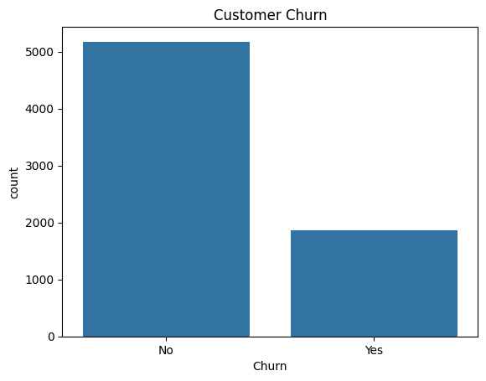
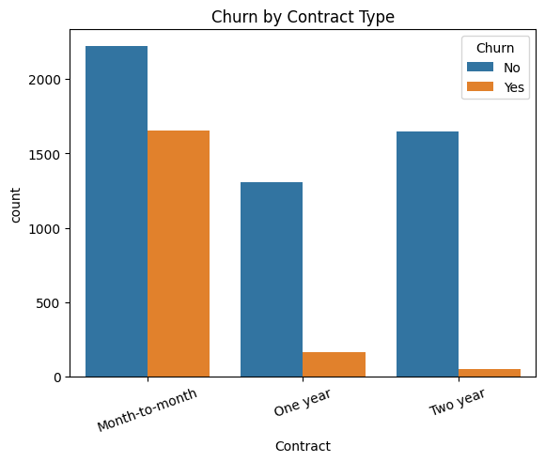

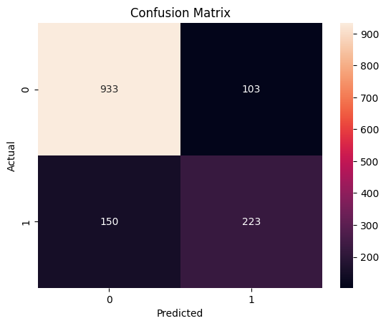

Result
The customer churn dataset was successfully imported, analyzed, visualized, and processed. A Logistic Regression model was trained to predict customer churn, and the model performance was evaluated using accuracy and a confusion matrix. The processed data was also exported to an Excel file.

